**ECG-based Biometric Authentication using**

**Empirical Mode Decomposition and Support Vector**

**Machines**

**CHAPTER -1**

**ABSTRACT**

Electrocardiogram (ECG) is an electric signal of cardiac activity posing highly discriminative properties related to human recognition. ECG based authentication has gained much success in recent times however discriminant feature extraction and efficient pattern classification still encounter numerous challenges. This paper proposed a novel methodology for ECG based biometric authentication system. Proposed method first denoise single lead raw ECG signal through empirical mode decomposition (EMD). Region of interest from ECG signals having maximum characteristic information related to subject’s recognition is also extracted through EMD. Next, feature extraction is performed by combination of five features from statistical, time and frequency domains. Finally, selected features were categorized with range of different classification methods such as Support Vector Machines (SVM), K-nearest neighbor (KNN) and Decision Tree (DT). 10-fold cross validation based classification evaluation reveals that SVM with cubic kernel achieves best accuracy of 98.7%, sensitivity of 100% and 98.8% specificity for successful classification of 14 subjects.

Keywords: —Biomedical recognition system, Electrocardiogram, Biometric authentication, Empirical mode decomposition, Support vector machines, Feature extraction

**CHAPTER-2**

**INTRODUCTION**

In today’s world of automation and technology, biometrics has become a major tool for the purpose authentication and identification. A major advantage of a biometric system is its full dependency on the individual. At the same time where fingerprints and face recognition are used for this purpose a new type of biometrics i.e. the medical biometrics is gaining pace. Medical biometrics is used to achieve the same motive of identification and authentication by using biological signals like Electrocardiogram (ECG). Biometric features are the characteristics that are unique to a single individual that acts as a basis for the identification of that individual from the rest of the population. Out of all the medical signals, ECG is the ultimate signal used for this purpose because it is unique for every individual and this uniqueness can be exploited by looking at different features of ECG. One of the biggest advantage of using a ECG biometric system is that it also guarantees the presence and aliveness of the person and also it is most difficult to counterfeit as compared to fingerprint of a person which can be forged , voice recording of a person in his absence can be used and iris images can be used in iris based recognition but such tactics cannot be used in ECG biometrics.

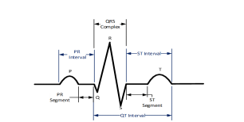  
Figure 1: Components of ECG signal

There are three main components to an ECG: the P wave, which represents depolarization of the atria; the QRS complex, which represents depolarization of the ventricles; and the T wave, which represents repolarization of the ventricles.

**P wave:** The depolarization front generates the P wave, which is a summation wave, as it passes through the atria. Since the depolarization wave begins in the sinoatrial node and the high right atrium before passing through and into the left atrium, the right atrium often depolarizes a little bit earlier than the left atrium. Uniformly shaped waves are produced as the depolarization front travels through the atria over semi-specialized conduction channels, such as Bachmann's bundle. Atrial ectopics (other depolarization in the atria) cause P waves to have a different morphology from what is typical.

**QRS Complex**: Three of the visual deflections seen on a typical electrocardiogram combine to form the QRS complex (ECG or EKG). It is typically the most prominent and central area of the trace. It is the same as the heart's right and left ventricles depolarizing and contracting their big ventricular muscles.The QRS complex typically lasts 80 to 100 ms in adults; it may be shorter in children. The Q, R, and S waves all follow one another quickly, represent the same occurrence, and do not all show in all leads. For these reasons, they are frequently grouped together. Any downward deflection that comes right after the P wave is known as a Q wave. The S wave is any downward deflection that occurs after the R wave, which follows as an upward deflection. The S wave is followed by the T wave, and in some circumstances, a subsequent U wave. Start from the end of the PR interval (or the beginning of the Q wave) and go to the end of the S wave to calculate the QRS interval. This gap typically lasts 0.08 to 0.10 seconds. A wide QRS complex is thought to exist when the duration is prolonged.

**T wave:** The T wave in electrocardiography represents the ventricles' repolarization. The absolute refractory period is the stretch of time between the start of the QRS complex and the peak of the T wave. The relative refractory period, also known as the susceptible period, is the second half of the T wave. The QT interval is less informative than the T wave. The T wave's symmetry, skewness, slope of the ascending and descending limbs, amplitude, and subintervals such the T peak-Tend interval can all be used to describe it. The T wave is typically positive in leads. The membrane's repolarization is to blame for this. The heart depolarizes during ventricular contraction (QRS complex). Repolarization, which occurs in the ventricle in the opposite direction of depolarization and is characterised by negative current, denotes the relaxation of the ventricles' heart muscle. Even though the cell becomes more negatively charged as a result of this negative flow, the net result is positive, and the ECG registers this as a positive spike.  A negative T wave, however, is typical in lead aVR. Usually, the T wave in lead V1 is negative. A negative T wave can also occasionally be seen in lead III, aVL, or aVF.

Electrical currents are generated at the Sinoatrial node (SA) node of heart and travel down to the Atrioventricular (AV) node and spread not only within the heart but also throughout the body. These electrical currents known as the ECG can be measured with the help of surface electrodes. ECG signal consists of P wave that represents atrial depolarization or more commonly known as contraction of atria. The QRS complex in ECG signal shows ventricular depolarization or ventricular contraction and T wave represents ventricular repolarization or ventricular relaxation. Normal ECG signal is shown in Fig. 1.

In order to understand how ECG is suitable for a biometric system, we need to know the requirements of a biometric system. An "ultimate" biometric characteristic as described by should be:

• Universal in terms of each individual possessing it

• Easily measured

• Unique

• Permanent, i.e., it cannot be forged

ECG based authentication was performed through self developed algorithm using two electrodes ECG. This work utilized Physionet ECG dataset and achieved 84.93% accuracy. Classification of various subjects by extracting multiscale features from ECG signal was performed. The data used was taken from Physikalisch-Technische Bundesanstalt (PTB) database and reported true positive rate of 91.67%.Non-fiducial point base technique was utilized for defining features. Authors used MIT-BIH Normal Sinus Rhythm database from PhysioNet.

In [9], authors proposed a method for authentication using ECG signals obtained from chest sensors. Feature extraction was performed through dynamic time warping with an error rate of 6% to 13%. In another similar study [10], authors proposed an ECG authentication system. Feature extraction was performed through Discrete Wavelet Transform (DWT). Sum of Squared Difference technique was used for template matching. An accuracy of 91 % was achieved. In [11] ECG signals taken from Physionet database [7] were classified through neural network and SVM. The accuracy rate was 96.6% and 97.6%.

In [12], ECG biometric authentication system including dataset from BioSec Lab [13, 14], based on Gaussian one class and binary SVM classifiers was proposed. Data in this case was preprocessed through DWT. In [15], authors presented authentication technology in which data was collected after extensive exercise. 55 subjects were included in experimentation. Biopac MP150 was used for data acquisition and classification was done by linear discriminant analysis (LDA). A maximum accuracy of 96.22% within 5 minutes recordings was achieved. Human recognition system using single lead electrocardiogram (ECG) from PTB dataset [7] was proposed in [10]. Finite Impulse Response (FIR) high pass filter was used for preprocessing ECG signal. Haar wavelet transform was applied for detection and an accuracy of 97.12% was achieved. Another similar study used a 12-lead resting ECG database for ECG biometric authentication [16]. Cross correlation method and amplitude measurements were used for feature extraction and LDA as a classifier to achieve maximum accuracy of 96.13%. Authors in [17] proposed strategies for Electrocardiogram (ECG) based identification using Deep Neural Network. An average accuracy of 94.39% was obtained. In [18], authors proposed a Cascaded PCA Network that was based on principal component analysis network (PCANet) to build an ECG biometric system and an accuracy of 93.3% was achieved. Deep convolutional neural network based on three kernels was utilized in [19] to obtain 4.74% error rate. Reference [20] used a neural network based classification for live ECG biometric system with an accuracy of 97.9%. In [21] four different nonlinear methods were applied for feature extraction and SVM was used as a classifier and an accuracy of 99.06±0.26% was achieved. In [22] ECG data from MIT-BIH database was used on which filters and multi-layer neural networks were used to design an ECG recognition system with a maximum accuracy of 98.65%. Authors in [23] proposed a system based on the diffusion maps algorithm and the Scattering Transform with an accuracy of 97.25%. In this work, we applied empirical mode decomposition (EMD) for removing artifacts and extraction of region of interest from raw ECG signal. Afterwards, feature extraction is performed by extracting useful and representative features of time, frequency and statistical domain. Selected five features were analyzed through variety of classification methods and SVM based classifier achieved best performance.

**CHAPTER-3**

**LITERATURE REVIEW**

**[1] P. Huang, L. Guo, M. Li, and Y. Fang:** In this paper patients use various types of medical IoT devices for monitoring their health conditions. The collected information (personal health records) will be sent back to hospitals for diagnosis and quick responses. However, severe security and privacy leakages with regard to data privacy and identity authentication are incurred because the monitored health data contains sensitive information. Therefore, the data should be well protected from unauthorized entities. Unfortunately, traditional cryptographic approaches or password-based mechanisms cannot fulfill the privacy and security demands in health monitoring due to their low efficiency and knowledgebased property. Biometric authentication overcomes these deficiencies and successfully verifies the inherent characteristics of humans. Among all biometrics, the electrocardiogram (ECG) signal is the most suitable one due to its medical properties. However, the security and privacy objectives of ECG-based authentication usually fail in practice due to the noise interferences in the collected ECG data and the privacy breach of the ECG database. In this work, we propose a practical scheme that can reliably authenticate patients with noisy ECG signals and provide differentially private protection simultaneously. The effectiveness and efficiency of our scheme are thoroughly analyzed and evaluated over online datasets. We also conduct a pilot study on human subjects experiencing different exercise levels to validate our scheme.

**Summary**: Studied about ECG-based authentication scheme for IoT-based healthcare that provides authentication ability when the ECG input is noisy and protects the privacy of stored ECG templates.

**[2] S. S. Abdeldayem and T. Bourlai :** Electrocardiography (ECG) is the process of recording the electrical activity of the human heart over time using electrodes that are placed over the skin. While the primary usage of electrocardiograms, the recorded signals, has been focused on the check of signs of heart-related diseases, recent studies have moved also toward their usage for human authentication. Thus, an ECG signal can be unique enough to be used independently as a biometric modality. In addition to its inherent liveness detection, it is easy to collect and can be easily captured either via sensors attached to the human body (fingertips, chest, wrist) or even passively using wireless sensors. In this paper, we propose a novel approach that exploits the spectro-temporal dynamic characteristics of the ECG signal to establish personal recognition system using both short-time Fourier transform (STFT) and generalized Morse wavelets (CWT). This process results in enriching the information extracted from the original ECG signal that is inserted in a 2D convolutional neural network (CNN) which extracts higher level and subject-specific ECG-based features for each individual. To validate our proposed CNN model, we performed nested cross-validation using eight different ECG databases. These databases are considered challenging since they include both normal and abnormal heartbeats as well as a dynamic number of subjects. Our proposed algorithms yield superior performance when compared to other state-ofart approaches discussed in the literature, i.e. the STFT-based one achieves an average identification rate, equal error rate (EER), and area under curve (AUC) of 97.86%, 0.0268, and 0.9933 respectively, whereas the CWT achieves comparable to STFT results in 97.5%, 0.0386, and 0.9882 respectively

**Summary:** Studied the utilization of the deep convolutional neural network and the spectro-temporal changes of the ECG signal. The shorttime Fourier transform (STFT) as well as generalized Morse wavelets (CWT) were studied in our proposed approach. The models’ validation was done using different eight ECG databases that include both normal and abnormal heartbeats.

**[3] T. S. J. P. Lugovaya:**The ECG (electrocardiogram) is an emerging technology for biometric human identification. In this paper, the performance of an ECG biometric recognition system is evaluated. Signal processing techniques are utilized to extract the ECG features. In preprocessing stage, digital filters eliminate the noises and hence improve the signal to noise ratio. The process of ventricular complex (QRS Complex) detection depends on Pan and Tompkins approach that achieves an efficient QRS detection, and hence enhancing the feature extraction process. The main classifiers applied to the extracted features are Neural Network (NN), Fuzzy Logic (FL), Nearest Mean Classifier (NMC), Linear Discriminant Analysis (LDA), and Euclidean Distance (ED) are utilized to classify QRS fragments. ECG of an unknown subject is acquired; the classifiers are applied to wavelet coefficient features set between the unknown subject and all enrolled subjects. The Performance of the different approaches is evaluated by utilizing Sensitivity, Specificity, and efficiency, EER (Equal Error Rate) and ROC (Receiver Operating Characteristic) curve. The experiments are conducted on 112 individuals MIT-BIH database and the accuracy is up to 98.99%.

**Summary:** Investigated about we several classifiers with the same MIT_BIT dataset. The yielded results demonstrate that the performance of all algorithms is high enough. Although the NN classifier achieves performance better than the other algorithms (FL, NMC, LDA, and ED). The performance of these classifiers is evaluated using Sensitivity, Specificity, efficiency, ROC curve and EER.

**[4] J. S. Arteaga-Falconi, H. Al Osman:** Traditional mobile login methods, like numerical or graphical passwords, are vulnerable to passive attacks. It is common for intruders to gain access to personal information of their victims by watching them enter their passwords into their mobile screens from a close proximity. With this in mind, a mobile biometric authentication algorithm based on electrocardiogram (ECG) is proposed. With this algorithm, the user will only need to touch two ECG electrodes (lead I) of the mobile device to gain access. The algorithm was tested with a cell phone case heart monitor in a controlled laboratory experiment at different times and conditions with ten subjects and also with 73 records obtained from the Physionet database. The obtained results reveal that our algorithm has 1.41% false acceptance rate and 81.82% true acceptance rate with 4 s of signal acquisition. To the best of our knowledge, this is the first approach on mobile authentication that uses ECG biometric signals and it shows a promising future for this technology. Nonetheless, further improvements are still needed to optimize accuracy while maintaining a short acquisition time for authentication.

**Summary:** Studied new ECG authentication algorithm that can be used in mobile devices. The algorithm was tested with a sensor designed for a mobile environment. The obtained results show that the algorithm is suitable to work with mobiles and with other sensors; as it was tested also with Physionet database

**[5]** **M. K. Bashar, Y. Ohta, and H. Yoshida :**ECG-based based human recognition is increasingly becoming a popular modality for biometric authentication. Two important features of ECG signals are liveliness and the robustness against falsification. However, ECG features vary due to muscle flexure, baseline wander, and other sources of noise. This paper presents a new method which extracts multiscale geometric features from ECG signals and apply them for human identification. A non-linear filter is applied for preprocessing the ECG signal. The refined ECG signal is then divided into multiple segments and feature matrix is computed by multiscale pattern extraction technique. Feature matrix is finally applied to a simple minimum distance to mean classifier adopting leave-one-out procedure. An experiment with 60 ECG signals from 60 subjects shows promising performance of the proposed method compared to the conventional ECG features.

**Summary:** Studied r human identification from ECG signal. The method computed multiscale pattern distribution feature for human identification. An experiment with 60 ECG signals from 60 subjects showed promising accuracy of identifying humans from database.

**CHAPTER-4**

**EXISTING METHOD**

The flow chart of proposed algorithm is depicted in Fig. 2. The algorithm consists of two parts, registration and authentication. In registration process feature of templates are extracted by using discreet wavelet transform (DWT) and stored. In authentication step the features for template are extracted by DWT. For template matching we use Sum of Squared Difference (SSD).

In Discreet Wavelet Transform a signal is decomposed as shown in Fig. 3 by passing it through high pass filter called decimation and a low pass filter called approximation, as shown in Fig. 4. In next level the approximation is further decomposed by passing it through high pass and low pass filter and so on depending upon levels to decompose the signal.

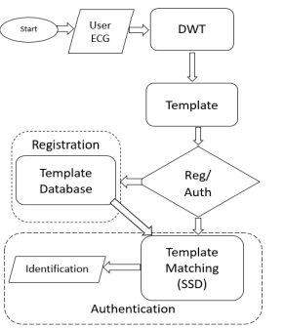

Figure 2. Flow chart of Existing Algorithm



Where i is scaling and j is translation parameters of mother wavelet. Different levels of wavelet transform of ECG to identify uniqueness of each person and variation in different persons were used in the paper. It is observed that most of uniqueness is found in higher frequencies as shown in Fig. 5 lower frequencies are found unstable and effects results badly. We choose our features from “d1” of wavelets, ignoring zeros from start and end by using differentiation and we get features for our template.

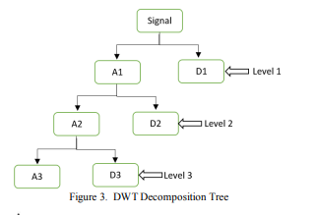

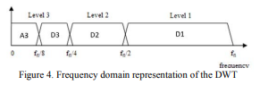

In template matching we use Sum of Squared Difference(SSD) algorithm, in SSD the similarity between two templates is calculated by given formula



Where xk is feature of registered template and yk is from authentication template, N represent total number of features. After calculating similarity, a threshold is used to decide either given template is matched or not. SSD is simple and gives better results as compared to correlation used in template matching.

In Biometrics template matching relatively simpler than classification i.e. using SVM, neural network, etc. In classification whenever a new person register itself, it is needed to train classifier each time (for training dataset must be stored), it takes significant time specially in case of neural networks etc. In template matching whenever a new person register itself, its template is stored and during authentication it is matched with other templates. It saves much computation and time which is one of the requirement of IoT due to hardware limitations.

**DISADVANTAGES:**

1. Shift-Sensitivity

2. Unpredictable change in the output coefficients

3. Poor directional selectivity

5. Lack of Directionality

6.Alasing

**CHAPTER-5**

**PROPOSED METHOD**

In this section, Fig. 2 illustrates detailed block diagram of the proposed ECG based biometric classification system. Data acquired from ECG electrodes is preprocessed through EMD. EMD decomposes input signal into sub-components called intrinsic mode functions (IMFs). Region of interest is extracted from ECG signal that carry discriminative information about every individual/subject. Redundant information and noise are discarded by removing those signal components from resultant preprocessed signal Fig. 2 illustrates detailed block diagram of the proposed ECG based biometric classification system. Data acquired from ECG electrodes is preprocessed through EMD. EMD decomposes input signal into sub-components called intrinsic mode functions (IMFs). Region of interest is extracted from ECG signal that carry discriminative information about every individual/subject. Redundant information and noise are discarded by removing those signal components from resultant preprocessed signal

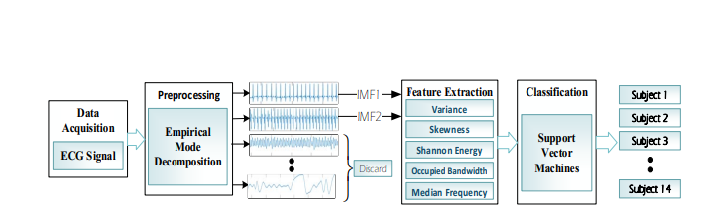

Figure 2: Sketch of the proposed ECG-based Biometric System

IMF1 and IMF2 were added to get the required preprocessed signal, while other IMFs are ignored. Next, feature extraction is performed on preprocessed signal. ECG signal characterization is achieved through combination of Shannon energy, occupied bandwidth, median frequency and statistical features such as variance and skewness. Selected discriminant features are fed to multiclass SVM model for classifying different classes.

1. Data Acquisition

ECG signal data for this study is acquired using BIOPAC systems. SS2L Electrode Lead Set and body surface electrodes were utilized for collecting ECG data. The electrodes were clipped to right forearm, left leg and right leg. The dataset accommodates ECG records of 14 subjects which includes 8 males and 6 females at rest. All ECG records are sampled at sampling frequency of 1000 Hz. Each raw data file is segmented into smaller equal files containing 10,000 samples each. These segmented files are then preprocessed and fed into the classifier. Time domains and frequency domains of the raw signals acquired.

B. Preprocessing and segmentation

The Raw ECG signals is disrupted due to a number of noises like artifacts, power line interference etc. In order to make it suitable for a biometric system, this signal needs to be preprocessed or denoised. Empirical mode decomposition (EMD) is a recent and adaptive method that expands a signal into a compression of Intrinsic Mode Functions (IMFs) [24- 26]. EMD is especially suitable for signals that show nonlinearity and are non-stationary like ECG [27].The initial IMFs represent high frequency information while the latter shows low frequency information and in case of ECG represents artifacts. Every IMF should have certain properties;

• Total extrema and zero crossings of the IMFs should either be equal or differ only by one.

• There should be symmetry of IMF with respect to the zero local mean[25]

EMD is applied to the raw ECG signal acquired and a number of IMFs and residual are obtained

only IMF 1 and IMF 2 represent the denoised ECG while the rest represent noise. So in order to make the signal suitable for the biometric system we make a new signal by combining IMF 1 and IMF 2 .Time domains and frequency domains of the pre-processed signal are shown in Fig. 6 and 7. This selection process also performs region of interest extraction from ECG signal for our target biometric application, as only those IMFs are selected which carry highly decisive information related to different subjects. Information which is redundant and could deteriorate classification performance is removed from resultant preprocessed signal. C. Feature Extraction An ECG biometric system is based upon the recognition of ECG of different subjects. A good recognition system should depend upon features that are able to distinguish the signal of a particular individual from another individual [28]. After rejecting noisy signal segments and extraction of region of interest, ECG signals were distinguished on the basis of following extracted features;

• Shannon energy

• Skewness

• Variance

• Occupied bandwidth

• Median frequency

1. Shannon Energy

Shannon energy is a parameter that is used to calculate the average spectrum of the energy of the signal. It discounts the high components into low components and hence the input amplitude is of no significance. Shannon energy calculates the spectrum energy of each sample[29]. It is described mathematically in below equation;



where, n is after normalization process

1. Skewness

Skewness is another important feature that is described as the average of the cubed deviation from the mean divided by the cubed standard deviation. Skewness is a measure of the symmetry of the distribution of the samples around the R peak region and its value can be positive, negative or undefined [30]. The mathematical expression for skewness is given in equation below;



Where, Ybar represents the mean

S is the standard deviation

N shows data points of the normal ECG signal

1. Variance Variance is defined as the squared variation of a variable from its mean value. It measures how far a set of random values is spread from its normal mean value. In a given signal like ECG, the larger the variance is, the more big of amplitude variation[31]. Mathematically variance is defined in equation below ;



Where, N shows length of the signal

Xbar is the mean of the signal

1. Occupied Bandwidth

Occupied Bandwidth abbreviated as (OBW) is the bandwidth containing 99% of the total integrated power of the transmitted spectrum, centered on the assigned channel frequency. It is usually concerned with the QT complex of the ECG signal [32].

1. Median Frequency

Median frequency is another feature that aids the discrimination of ECG signals in a group of different subjects. Median frequency is defined as the normalized frequency of the median of power spectrum of the R peak region[33]

D. Classification – Support Vector Machines

Support Vector Machines (SVM) is widely applied as a best choice classifier for biomedical signal analysis applications. SVM is a pattern identification method [28] in which a set of training features is segregated by SVM with a maximum margin from hyper plane. In case when linear separation is not possible, non-linear kernel modifications can be applied. Different kernels quadratic, polynomial and radial basis function can be opted [34]. The choice of proper kernel function relies on specific data [35]. The employed features include Shannon energy, Skewness, Variance, Occupied bandwidth and Median frequency. The classifier resulted in accuracy of 99.2%.

**CHAPTER-6**

**ADVANTAGES AND APPLICATIONS**

**Advantages:**

1. It is relatively easy to understand and use
2. It does not require predetermined set of mathematical functions
3. Adequate for both the linear and the stationary

**Applications:**

1.guidance, navigation,

2. control of vehicles, particularly aircraft, spacecraft and ships positioned dynamically.

3.Image Processing,

4.Medical Signal processing.

5.Signal Processing

**CHAPTER-7**

**MATLAB**

**7.1 INTRODUCTION TO MATLAB**

**What Is MATLAB?**

MATLAB is an elite dialect for specialized registering. It incorporates calculation, representation, and programming in an easy to-utilize condition wherein issues and preparations are communicated in herbal numerical documentation. Run of the mill utilizes comprise

• Math and calculation

• Algorithm advancement

• Data obtaining

• Modeling, re-enactment, and prototyping

• Data examination, investigation, and representation

• Scientific and designing illustrations

• Application advancement, including graphical UI building

MATLAB is an intuitive framework whose important statistics aspect is an show off that does not require dimensioning. This allows you to tackle several specialized processing issues, particularly those with framework and vector info, in a small quantity of the time it'd take to compose a program in a scalar non intuitive dialect, as an instance, C or FORTRAN.

The call MATLAB stays for grid studies facility. MATLAB changed into first of all composed to present easy access to framework programming created by way of the LINPACK and EISPACK ventures. Today, MATLAB motors fuse the LAPACK and BLAS libraries, inserting the cutting side in programming for network calculation.

MATLAB has advanced over a time of years with contribution from several customers. In university situations, it's far the usual academic apparatus for early on and propelled guides in mathematics, designing, and science. In enterprise, MATLAB is the tool of choice for excessive-profitability studies, advancement, and exam.

MATLAB highlights a collection of more utility-specific arrangements known as tool booths. Important to most clients of MATLAB, device kits permit you to learnandapply particular innovation. Tool compartments are exhaustive accumulations of MATLAB capacities (M-records) that reach out the MATLAB condition to take care of precise training of problems. Territories in which tool stash are reachable include flag coping with, manipulate frameworks, neural structures, fluffy reason, wavelets, pastime, and severa others.

**The MATLAB System:**

The MATLAB system consists of five main parts.

**Development Environment:**

 This is the set of tools and centres that help you operate MATLAB features and files. Many of that gear are graphical person interfaces. It includes the MATLAB desktop and Command Window, a command history, an editor and debugger, and browsers for viewing assist, the workspace, files, and the hunt direction.

**The MATLAB Mathematical Function:**

This is a great collection of computational algorithms ranging from standard capabilities like sum, sine, cosine, and complex arithmetic, to extra sophisticated features like matrix inverse, matrix eigen values, Bessel functions, and speedy Fourier transforms.

**The MATLAB Language:**

This is a high-level matrix/array language with control flow statements, functions, data structures, input/output, and object-oriented programming features. It allows both "programming in the small" to rapidly create quick and dirty throw-away programs, and "programming in the large" to create complete large and complex application programs.

**Graphics:**

MATLAB has considerable centres for displaying vectors and matrices as graphs, as well as annotating and printing those graphs. It consists of high-stage functions for 2-dimensional and 3-dimensional records visualization, photograph processing, animation, and presentation graphics. It also consists of low-stage capabilities that will let you absolutely customise the appearance of graphics as well as to construct complete graphical person interfaces for your MATLAB programs.

**The MATLAB Application Program Interface (API):**

This is a library that allows you to put in writing C and Fortran applications that have interaction with MATLAB. It consists of facilities for calling workouts from MATLAB (dynamic linking), calling MATLAB as a computational engine, and for studying and writing MAT-documents.

**7.2 MATLAB WORKING ENVIRONMENT:**

## MATLAB DESKTOP:

Matlab Desktop is the principle Matlab application window. The desktop consists of five sub windows, the summon window, the workspace program, the existing catalog window, the order records window, and at the least one figure home windows, which can be proven simply while the consumer suggests a sensible.

The order window is the area the customer sorts MATLAB orders and expressions at the initiate (>>) and wherein the yield of these fees is shown. MATLAB characterizes the workspace because the association of factors that the customer makes in a work session. The workspace software demonstrates these elements and some statistics approximately them. Double tapping on a variable within the workspace application dispatches the Array Editor, which may be applied to get data and salary instances modify sure homes of the variable.

The present Directory tab over the workspace tab demonstrates the substance of the existing registry, whose way is seemed within the present index window. 1For case, within the windows running framework the manner may be as consistent with the subsequent: C:MATLABWork, demonstrating that registry "paintings" is a subdirectory of the primary catalog "MATLAB", which is delivered in pressure C. Tapping on the bolt inside the present index window demonstrates a rundown of as of past due utilized approaches. Tapping at the seize to one aspect of the window enables the client to exchange the existing catalog.

MATLAB utilizes an inquiry way to discover M-data and different MATLAB related documents, which might be sort out in catalogs within the PC file framework. Any file keep strolling in MATLAB must dwell inside the ebb and go with the flow registry or in an index that is on are trying to find manner. Of direction, the statistics supplied with MATLAB and math works device kits are included into the inquiry way. The least stressful method to look which indexes are at the inquiry manner. The handiest method to peer which catalogs are soon the quest way, or to encompass or regulate an inquiry manner, is to pick set manner from the File menu the computer, and after that utilization the set way exchange container. It is exquisite exercise to add any typically utilized catalogs to the pursuit way to hold a strategic distance from again and again having the exchange the existing index.

The Command History Window contains a record of the orders a client has entered in the charge window, including both present and past MATLAB sessions. Already entered MATLAB orders can be chosen and re-executed from the charge history window by right

tapping on a summon or arrangement of orders. This activity dispatches a menu from which to choose different choices notwithstanding executing the orders. This is helpful to choose different choices notwithstanding executing the summons. This is a valuable component while trying different things with different orders in a work session

**Using the MATLAB Editor to create M-Files:**

The MATLAB manager is both a word processor unique for making M-statistics and a graphical MATLAB debugger. The proofreader can display up in a window without everybody else, or it could be a sub window in the laptop. M-facts are intended by means of the expansion .M, as in pixelup.M. The MATLAB editorial manager window has various draw down menus for errands, for instance, sparing, seeing, and troubleshooting documents. Since it plays out a few basic checks and furthermore utilizes shading to separate between exclusive additives of code, this content device is suggested as the equipment of selection for composing and changing M-capacities. To open the proofreader, sort regulate at the incite opens the M-report filename.M in a supervisor window, organized for altering. As referred to before, the record has to be inside the momentum catalog, or in an index within the pursuit manner.

**Getting Help:**

The important technique to get help on line is to utilize the MATLAB assist application, opened as a exclusive window both via tapping at the query mark image at the computing device toolbar, or by using writing help program on the provoke within the order window. The help Browser is an internet application coordinated into the MATLAB computing device that shows a Hypertext Markup Language (HTML) statistics. The Help Browser contains of two sheets, the assistance pilot sheet, used to find out data, and the show sheet, used to look the statistics. Clear as crystal tabs aside from pilot sheet are applied to play out a pursuit. Second, within the motion pictures taken via transferring camera setup, the state of affairs becomes extra complex because the heritage may additionally exchange by using shifting shot, we cannot tune item motion exactly inside the sum of distinction map. Therefore, in this situation, the purpose is executed through reusing the previous seam and applying it to the cutting-edge body. In order to discover the seams, we use the preceding seam from previous body to look the modern-day seam in contemporary frame. our method is using a seam computed in frame1 (in crimson) to go looking a comparable seam in frame2. For the pixels close by the area of previous seam, we decide how a lot the selected pixel might vary from the pixel of preceding seam. We use difference of the 2 pixels as the degree of temporal coherence. If the distinction value of first seam pixel is over the threshold, we can keep to go looking the next seam pixel on three feasible pixels (in yellow, blue and brown) in subsequent row, until we discover 5 consecutive pixels that also exceed the threshold.

When we can't search the matching seam, we recalculate the energy for a new seam. We assume a seam 𝑆l-1 has been calculated inside the previous body, and a seam must be calculated for the contemporary frame. For preserving the temporal coherence, we want to make a new seam close to the previous seam with the identical index. We use the distinction among preceding seam and all pixels at the current body as the measure

Thus we upload temporal coherence price Tc(i,j) to the strength map earlier than calculating a seam 𝑆L. The price Tc is zero while the body pixels have the equal fee as previous seam pixels. Using our temporal coherence price, we will calculate the seam which has least electricity and is more close to the preceding seam in previous frame. Consequently, we will decrease the jittery artifacts inside the films.

**COMMUNICATION:**

Communications System Toolbox™ offers algorithms and gear for the layout, simulation, and analysis of communications systems. These capabilities are furnished as MATLAB ® features, MATLAB System gadgets™, and Simulink ® blocks. The machine toolbox includes algorithms for source coding, channel coding, interleaving, modulation, equalization, synchronization, and channel modeling. Tools are supplied for bit blunders charge evaluation, producing eye and constellation diagrams, and visualizing channel characteristics. The machine toolbox additionally provides adaptive algorithms that allow you to version dynamic communications structures that use OFDM, OFDMA, and MIMO techniques. Algorithms support fixed-point facts arithmetic and C or HDL code era.

**Key Features**

▪ Algorithms for designing the physical layer of communications systems, which includes supply coding, channel coding, interleaving, modulation, channel fashions, MIMO, equalization, and synchronization

▪ GPU-enabled System objects for computationally intensive algorithms together with Turbo, LDPC, and Viterbi decoders

▪ Interactive visualization equipment, consisting of eye diagrams, constellations, and channel scattering capabilities

▪ Graphical tool for evaluating the simulated bit mistakes rate of a machine with analytical outcomes

▪ Channel models, consisting of AWGN, Multipath Rayleigh Fading, Rician Fading, MIMO Multipath Fading, and

LTE MIMO Multipath Fading

▪ Basic RF impairments, along with nonlinearity, section noise, thermal noise, and section and frequency offsets

▪ Algorithms available as MATLAB features, MATLAB System objects, and Simulink blocks

▪ Support for fixed-point modeling and C and HDL code technology

**System Design, Characterization, and Visualization:**

The layout and simulation of a communications gadget requires analyzing its reaction to the noise and interference inherent in real-world environments, reading its behavior the usage of graphical and quantitative manner, and determining whether the resulting overall performance meets requirements of acceptability. Communications System Toolbox implements a selection of obligations for communications machine layout and simulation. Many of the functions, System objects™, and blocks inside the device toolbox perform computations associated with a specific thing of a communications gadget, consisting of a demodulator or equalizer. Other talents are designed for visualization or evaluation.

**System Characterization**

The system toolbox offers several standard methods for quantitatively characterizing system performance:

▪ Bit error rate (BER) computations

▪ Adjacent channel power ratio (ACPR) measurements

▪ Error vector magnitude (EVM) measurements

▪ Modulation error ratio (MER) measurements

Because BER computations are fundamental to the characterization of any communications system, the system toolbox provides the following tools and capabilities for configuring BER test scenarios and accelerating BER simulations:

**BER tool**— A graphical user interface that enables you to analyze BER performance of communications systems. You can analyze performance via a simulation-based, semi analytic, or theoretical approach.

**Error Rate Test Console** — A MATLAB object that runs simulations for communications systems to measure error rate performance. It supports user-specified test points and generation of parametric performance plots and surfaces. Accelerated performance can be realized when running on a multi core computing platform.

**Multi core and GPU acceleration** — A capability provided by Parallel Computing Toolbox™ that enables you to accelerate simulation performance using multi core and GPU hardware within your computer.

**Distributed computing and cloud computing support** — Capabilities provided by Parallel Computing Toolbox and MATLAB Distributed Computing Server™ that enable you to leverage the computing power of your server farms and the Amazon EC2 Web service. Performance Visualization. The system toolbox provides the following capabilities for visualizing system performance:

**Channel visualization tool** — For visualizing the characteristics of a fading channel

**Eye diagrams and signal constellation scatter plots** — for a qualitative, visual understanding of system behavior that enables you to make initial design decisions

**Signal trajectory plots** — for a continuous picture of the signal’s trajectory between decision points

**BER plots** — for visualizing quantitative BER performance of a design candidate, parameterized by metrics such as SNR and fixed-point word size

**Analog and Digital Modulation**

Analog and digital modulation strategies encode the facts circulation into a sign this is appropriate for transmission. Communications System Toolbox presents some of modulation and corresponding demodulation abilities. These talents are available as MATLAB features and gadgets, MATLAB System Modulation sorts provided by the toolbox are:

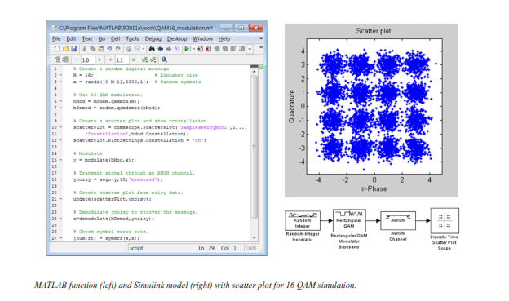**Source and Channel Coding**

Communications System Toolbox affords source and channel coding talents that can help you develop and compare communications architectures fast, enabling you to discover what-if eventualities and avoid the need to create coding competencies from scratch.

**Source Coding**

Source coding, also referred to as quantization or signal formatting, is a manner of processing facts a good way to lessen redundancy or prepare it for later processing. The system toolbox offers a diffusion of styles of algorithms for imposing source coding and interpreting, inclusive of:

▪ Quantizing

▪ Companding (*µ*-law and A-law)

▪ Differential pulse code modulation (DPCM)

▪ Huffman coding

▪ Arithmetic coding

**Channel Coding**

▪ orthogonal area-time block code (OSTBC) (encoder and decoder for MIMO channels)

▪ Turbo encoder and decoder examples

The gadget toolbox offers application functions for developing your personal channel coding. You can create generator polynomials and coefficients and syndrome deciphering tables, in addition to product parity-take a look at and generator matrices.

The system toolbox additionally presents block and convolutional interleaving and deinters leaving functions to reduce facts errors as a result of burst mistakes in a conversation machine:

**Block,** including General block interleaver, algebraic interleaver, helical scan interleaver, matrix interleaver, and random interleaver.

**Convolutional,** including General multiplexed interleaver, convolutional interleaver, and helical interleaver

**Channel Modeling and RF Impairments**

Channel Modeling

Communications System Toolbox provides algorithms and tools for modeling noise, fading, interference, and different distortions which might be commonly found in communications channels. The system toolbox supports the subsequent styles of channels:

▪ Additive white Gaussian noise (AWGN)

▪ Multiple-enter multiple-output (MIMO) fading

▪ Single-enter single-output (SISO), Rayleigh, and Rician fading

▪ Binary symmetric

A MATLAB channel object provides a concise, configurable implementation of channel models, enabling you to

specify parameters such as:

▪ Path delays

▪ Average path gains

▪ Maximum Doppler shifts

▪ K-Factor for Rician fading channels

▪ Doppler spectrum parameters

For MIMO systems, the MATLAB MIMO channel object expands these parameters to also include:

▪ Number of transmit antennas (up to 8)

▪ Number of receive antennas (up to 8)

▪ Transmit correlation matrix

▪ Receive correlation matrix

To combat the effects noise and channel corruption, the system toolbox provides block and convolutional coding and decoding techniques to implement error detection and correction. For simple error detection with no inherent correction, a cyclic redundancy check capability is also available. Channel coding capabilities provided by the system toolbox include:

▪ BCH encoder and decoder

▪ Reed-Solomon encoder and decoder

▪ LDPC encoder and decoder

▪ Convolutional encoder and Viterbi decoder

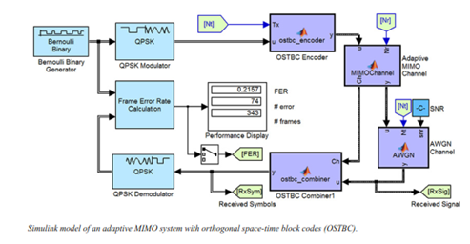

**RF Impairments**

To model the effects of a non-ideal RF front end, you can introduce the following impairments into your communications system, enabling you to explore and characterize performance with real-world effects:

▪ Memory less nonlinearity

▪ Phase and frequency offset

▪ Phase noise

▪ Thermal noise

You can include more complex RF impairments and RF circuit models in your design using SimRF™.

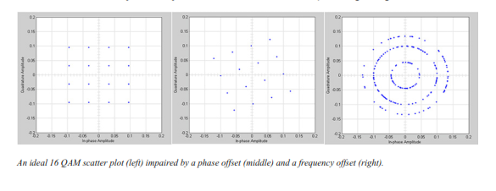

**Equalization and Synchronization**

Communications System Toolbox lets you discover equalization and synchronization strategies. These techniques are usually adaptive in nature and tough to design and symbolize. The machine toolbox affords algorithms and tools that will let you swiftly select the proper approach on your communications machine. Equalization To compare one-of-a-kind techniques to equalization, the device toolbox offers you with adaptive algorithms which include:

▪ LMS

▪ Normalized LMS

▪ Variable step LMS

▪ Signed LMS

▪ MLSE (Viterbi)

▪ RLS

▪ CMA

These adaptive equalizers are available as nonlinear decision feedback equalizer (DFE) implementations and as

Linear (symbol or fractionally spaced) equalizer implementations.

**Synchronization**

The device toolbox provides algorithms for each service segment synchronization and timing phase synchronization. For timing section synchronization, the machine toolbox presents a MATLAB Timing Phase Synchronizer object that offers the following implementation techniques:

▪ Early-late gate timing method

▪ Gardner’s method

▪ Fourth-order nonlinearity method

**Stream Processing in MATLAB and Simulink**

Most verbal exchange structures cope with streaming and frame-primarily based statistics using a aggregate of temporal processing and simultaneous multi frequency and multichannel processing. This form of streaming multidimensional processing can be visible in superior communication architectures consisting of OFDM and MIMO. Communications System Toolbox enables the simulation of advanced communications structures via helping move processing and frame-based simulation in MATLAB and Simulink. In MATLAB, circulate processing is enabled by way of System items™, which use MATLAB objects to symbolize time-based and facts-driven algorithms, sources, and sinks. System objects implicitly manipulate many information of flow processing, including information indexing, buffering, and management of set of rules state. You can mix System gadgets with fashionable MATLAB functions and operators. Most System items have a corresponding Simulink block with the identical abilities. Simulink handles circulation processing implicitly with the aid of coping with the float of information thru the blocks that make up a Simulink model. Simulink is an interactive graphical environment for modeling and simulating dynamic systems that uses hierarchical diagrams to symbolize a machine version. It includes a library of widespread-reason, predefined blocks to represent algorithms, resources, sinks, and device hierarchy.

**Implementing a Communications System**

Fixed-Point Modeling Many communications systems use hardware that requires a fixed-point representation of your design.

Communications System Toolbox supports fixed-point modeling in all relevant blocks and System objects™ with tools that help you configure fixed-point attributes.

Fixed-point support in the system toolbox includes:

▪ Word sizes from 1 to 128 bits

▪ Arbitrary binary-point placement

▪ Overflow handling methods (wrap or saturation)

▪ Rounding methods: ceiling, convergent, floor, nearest, round, simplest, and zero

Fixed-Point Tool in Simulink Fixed Point™ facilitates the conversion of floating-point data types to fixed point. For configuration of fixed-point properties, the tool tracks overflows and maxima and minima.

**Code Generation**

Once you've got advanced your set of rules or communications device, you can robotically generate C code from it for verification, rapid prototyping, and implementation. Most System gadgets, functions, and blocks in Communications System Toolbox can generate ANSI/ISO C code the use of MATLAB Coder™, Simulink Coder™, or Embedded Coder™. A subset of System gadgets and Simulink blocks also can generate HDL code. To leverage present highbrow belongings, you can choose optimizations for specific processor architectures and integrate legacy C code with the generated code.

You can also generate C code for both floating-point and fixed-point data types.

DSP Proto typing DSPs are used in communication system implementation for verification, rapid prototyping, or final hardware implementation. Using the processor-in-the-loop (PIL) simulation capability found in Embedded Coder, you can verify generated source code and compiled code by running your algorithm’s implementation code on a target processor. FPGA Prototyping

FPGAs are used in communication systems for implementing high-speed signal processing algorithms. Using the FPGA-in-the-loop (FIL) capability found in HDL Verifier™, you can test RTL code in real hardware for any existing HDL code, either manually written or automatically generated HDL code.

**CHAPTER -8**

**HARDWARE & SOFTWARE REQUIREMENTS:**

**Software:**

• Matlab R2018a.

**Hardware:**

**Operating Systems:**

• Windows 10

• Windows 7 Service Pack 1

• Windows Server 2019

• Windows Server 2016

**Processors:**

Minimum: Any Intel or AMD x86-64 processor

Recommended: Any Intel or AMD x86-64 processor with four logical cores and AVX2 instruction set support

**Disk:**

Minimum: 2.9 GB of HDD space for MATLAB only, 5-8 GB for a typical installation

Recommended: An SSD is recommended a full installation of all Math Works products may take up to 29 GB of disk space

**RAM:**

Minimum: 4 GB

Recommended: 8

**CHAPTER-9**

**RESULTS**

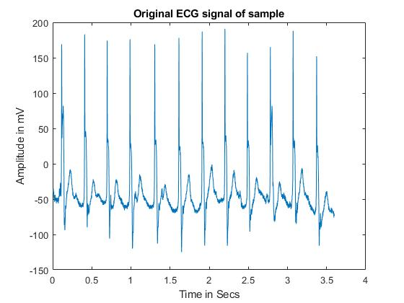

Figure :Original ECG Signal of Sample

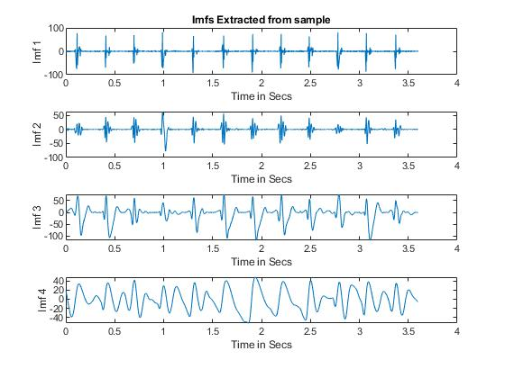

Figure :Imfs Extracted Samples

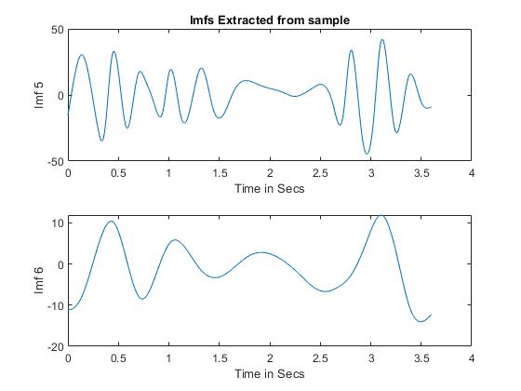

Figure: Imfs extracted samples

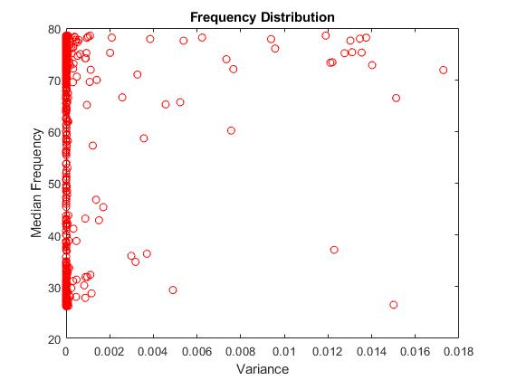

Figure : Frequency Distribution

**CHAPTER-10**

**CONCLUSION**

In conclusion, We proposed ECG based biometric authentication system. Proposed method employed EMD for region of interest extraction and signal denoising. Combination of time, frequency and statistical domain features were extracted to distinguish different data classes. Selected features were tested with eight different classification methods. SVM-C achieved highest classification accuracy of 98.72% with 10-fold cross validation strategy. Dataset for this study was collected from 14 different human subjects. Experimental analysis reveals that proposed method is reliable, accurate and computationally less expensive as compared to other studies. In future, we aim to expand the dataset by collecting ECG signals from more subjects in order to design highly reliable solution for authentication. We also aim to design embedded system for real time biometric applications based on proposed methodology. Such embedded systems can be used in various fields like eHealthcare to avoid the breach of medical information and banking etc.

**CHAPTER-11**

**REFERENCES**

[1] P. Huang, L. Guo, M. Li, and Y. Fang, "Practical Privacypreserving ECG-based Authentication for IoT-based Healthcare," IEEE Internet of Things Journal, 2019.

[2] S. S. Abdeldayem and T. Bourlai, "ECG-based Human Authentication using High-level Spectro-temporal Signal Features," in 2018 IEEE International Conference on Big Data (Big Data), 2018, pp. 4984-4993: IEEE.

[3] T. S. J. P. Lugovaya, "Biometric human identification based on ECG," 2005.

[4] J. S. Arteaga-Falconi, H. Al Osman, A. J. I. T. o. I. El Saddik, and Measurement, "ECG authentication for mobile devices," vol. 65, no. 3, pp. 591-600, 2015.

[5] Y. N. Singh and S. K. Singh, "Evaluation of electrocardiogram for biometric authentication," 2011.

[6] M. K. Bashar, Y. Ohta, and H. Yoshida, "ECG-based biometric authentication using mulscale descriptors: ECG-based biometric authentication," in 2015 International Conference on Intelligent Informatics and Biomedical Sciences (ICIIBMS), 2015, pp. 1-4: IEEE.

[7] A. L. Goldberger et al., "PhysioBank, PhysioToolkit, and PhysioNet: components of a new research resource for complex physiologic signals," vol. 101, no. 23, pp. e215-e220, 2000

[8] S. Gutta, Q. J. I. j. o. b. Cheng, and h. informatics, "Joint feature extraction and classifier design for ECG-based biometric recognition," vol. 20, no. 2, pp. 460-468, 2015.

[9] S. Šprager, R. Trobec, and M. B. Jurič, "Feasibility of biometric authentication using wearable ECG body sensor based on higherorder statistics," in 2017 40th International Convention on Information and Communication Technology, Electronics and Microelectronics (MIPRO), 2017, pp. 264-269: IEEE.

[10] A. Rehman, N. A. Saqib, S. M. Danial, and S. H. Ahmed, "ECG based authentication for remote patient monitoring in IoT by wavelets and template matching," in 2017 8th IEEE International Conference on Software Engineering and Service Science (ICSESS), 2017, pp. 91-94: IEEE.

[11] Y. Zhang and J. Wu, "Practical human authentication method based on piecewise corrected Electrocardiogram," in 2016 7th IEEE International Conference on Software Engineering and Service Science (ICSESS), 2016, pp. 300-303: IEEE.

[12] M. Hejazi, S. Al-Haddad, S. J. Hashim, A. F. A. Aziz, and Y. P. Singh, "Non-fiducial based ECG biometric authentication using one-class support vector machine," in 2017 Signal Processing: Algorithms, Architectures, Arrangements, and Applications (SPA), 2017, pp. 190-194: IEEE.

[13] H. P. Da Silva, A. Fred, A. Lourenço, and A. K. Jain, "Finger ECG signal for user authentication: Usability and performance," in 2013 IEEE Sixth International Conference on Biometrics: Theory, Applications and Systems (BTAS), 2013, pp. 1-8: IEEE.

[14] M. Hejazi, S. A. R. Al-Haddad, Y. P. Singh, S. J. Hashim, and A. F. A. J. D. S. P. Aziz, "ECG biometric authentication based on non-fiducial approach using kernel methods," vol. 52, pp. 72-86, 2016.

[15] D. Sung, J. Kim, M. Koh, and K. Park, "ECG authentication in post-exercise situation," in 2017 39th Annual International Conference of the IEEE Engineering in Medicine and Biology Society (EMBC), 2017, pp. 446-449: IEEE.

[16] V. Krasteva, I. Jekova, and R. J. J. o. e. Abächerli, "Biometric verification by cross-correlation analysis of 12-lead ECG patterns: Ranking of the most reliable peripheral and chest leads," vol. 50, no. 6, pp. 847-854, 2017.

[17] G. Zheng, S. Ji, M. Dai, and Y. Sun, "Ecg based identification by deep learning," in Chinese Conference on Biometric Recognition, 2017, pp. 503-510: Springer.

[18] J.-N. Lee, S. B. Pan, and K.-C. Kwak, "Individual identification Based on Cascaded PCANet from ECG Signal," in 2019 International Conference on Electronics, Information, and Communication (ICEIC), 2019, pp. 1-4: IEEE.

[19] Y. Chu, H. Shen, and K. Huang, "ECG Authentication Method Based on Parallel Multi-Scale One-Dimensional Residual Network With Center and Margin Loss," IEEE Access, vol. 7, pp. 51598-51607, 2019.

[20] L. Zhang, K. Xing, Z. Xu, J. Wang, S. Zhang, and J. Xu, "Human recognizer: An ECG based live biometric fingerprint," in Proceedings of the 1st ACM Workshop on Privacy-Aware Mobile Computing, 2016, pp. 21-27: ACM.